**U.S. Cross Country Fall Nationals 1986**

**San Francisco, CA**

**Golden Gate Park**

**November 29, 1986**

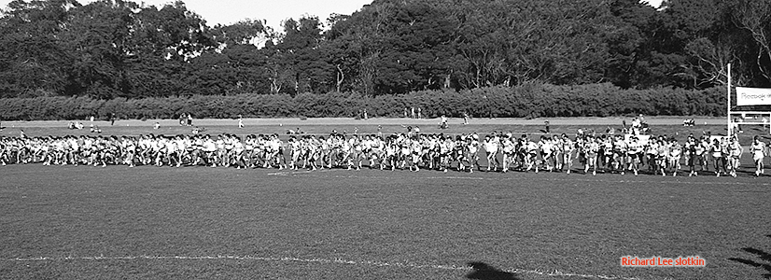

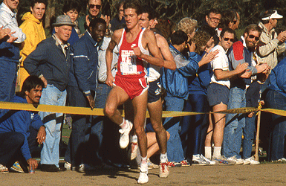

Pat Porter – 1st, 30:36

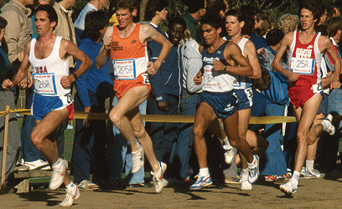

Thom Hunt leading chase pack

RESULTS (10,350 meters, 6.43 miles)

1. Pat Porter (AW) .................. 30:36

2. Steve Jones'(GB) ................ 30:46

3. Keith Hanson(Nik) .............. 30:47

4. Richard O'Flynn'(NBal) ....... 30:55

5. Art Boileau'(OTC) .............. 30:59

6. Chris Fox(AW) ................... 31:00

7. Paul Donovan'(Reeb) ........... 31:02

8. Marcus O'Sullivan'(NBal) .... 31:06

9. Thom Hunt(Nik) .................. 31:09

10. John Treacy'(NBal) ............ 31:11